WEEK 3 -THEORY
UI Architecture - Theme, Widgets, Screens

 Learning objectives
- Structure Flutter widgets for extendibility and consistency
- Comply with coding conventions
- Create a library of generic widgets aligned with a design system
- Understand the dart concepts of static methods, attributes

How to start?
- Create a GitHub repository for this project
- Get the start code, including the Figma Design System
- Ensure you can run the start project on your computer

How to submit?
- Make sure you follow the COMMIT standards (see below)
- Push the start code into your repository (commit: BLA-000- Start Code)
- Once finished, submit to MS Team:
  - GitHub URL
  - This document

You are not allowed to use AI to submit this work

ACTIVITY 1 – Analyze the model layer

The model layer - so far - is composed of 6 classes:
Ride, Location, Country, DateTime, User, RidePref

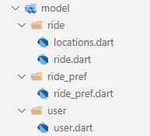

✏️ Draw the UML class diagram representing the relationships between those 6 classes.
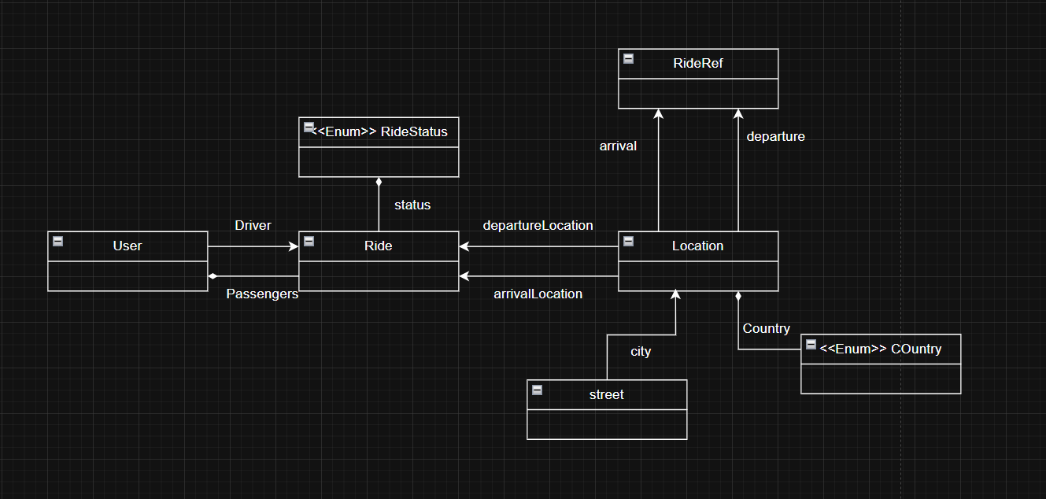
(no attribute, methods, just associations relationships)

✏️ What is the goal of the operator== and the hashCode method in Location class?
Operation == is comparing 2 object is logical the same, otherwise for hashCode gives each object a single number ID to find or use it quickly in collections like Set or Map.

ACTIVITY 2 – Understand the difference between instance and static access

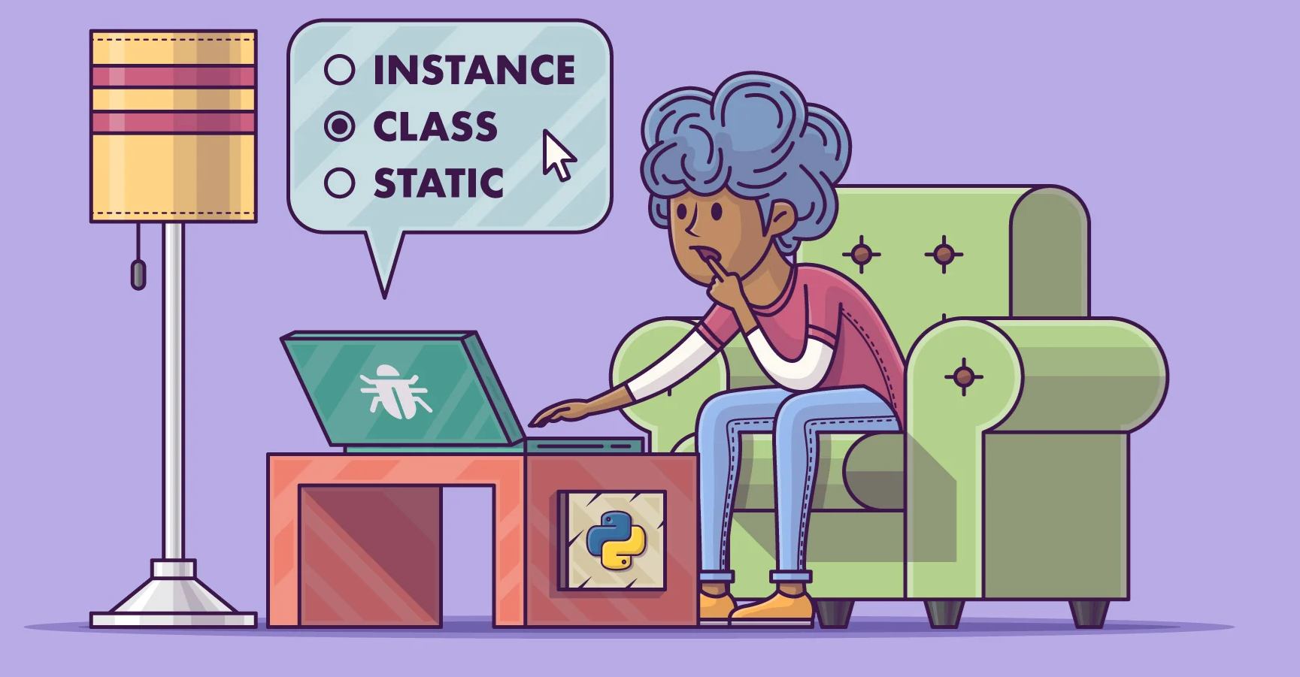
Answer the quiz in class

ACTIVITY 3 – Understand and analyze a first view: Ride Preferences screen

Let’s build step by step a Ride Preferences screen, showing only the past entered ride preferences.

✏️ Understand the methodology, steps, and coding standards to implement this view

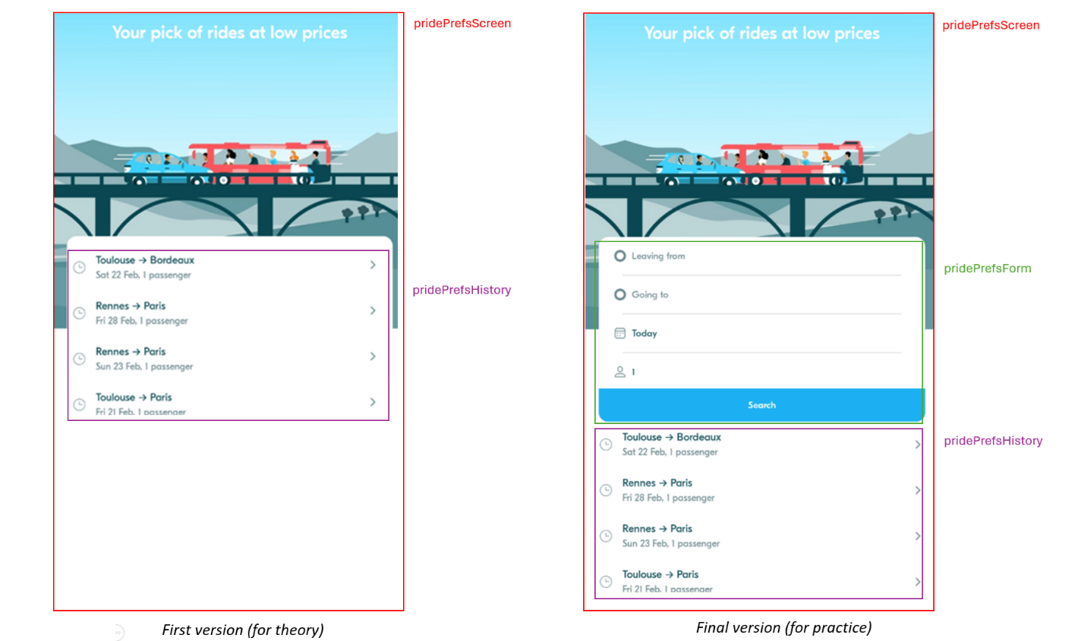

✏️Explain how the font (Eesti) is loaded from the assets and is applied to all widgets.
First you can define a Theme into a folder theme in a file name theme.dart then put any style and design then call it to use in the any file which is need a style by calling Theme.darkBlue following your declaration.

✏️ Analyze how the history tile interacts with the App theme.
History Tile | BlaTextStyle | BlaColor
title | Use a large and bold text style | Use primary or dark color for main text
subtile | Use a smaller and regular text style | Use secondary or gray color for less important text

✏️Explain how the date is converted into a readable label
Date is readable label when we converted it into a Datetime format there are
YYYY/MM/DD, or DD/MM/YYYY
For example: 2005/08/17, or 17/08/2005
This is a easy format to read

✏️ Analyze the Ride Preferences screen and complete the table.
Widget | Screen / Screen Widget /App Widget | Parameters | Callbacks
RidePrefScreen | Main screen for ride | None | onSave
BlaBackground | Reusable background component | Color | none
RidePrefHistoryTile | Display past ride | Title, subtitle, data and icon | onTap, onDelete, onEdit

✏️ At home, try to reproduce it by yourself (with the correction for help)

